Web Information System1 Project Outline

Geographic Information System (GIS) Based Police Database System:

Abstract

This project is called Geographic Information System (GIS) Based Police Database System. It is focused on the development and implementation of “Geographic Information System (GIS)-based Police Database System” which is aimed to simulate the actual process of crime data input, design a web-based interface, address issues in data input and show the functionality of the system.

GIS has been embraced by professionals in all areas of law enforcement for conducting day-to-day operations as well as for planning, analysis, and decision support". GIS plays a major role in generating crime maps in attaining efficiency in operations and rationality in the decision making process. Crime analysis is a method that will be used by law enforcement to reduce, prevent, and to solve crime, disorder, and quality of life issues. The system has several functions which are crime complaints recording, case investigation and statistics. By integrating GIS into, the user could see the analysis report in geographical form.

Currently, law enforcers are using traditional methods to record crime complaints, access the complaint for investigation and crime analysis. This method produced the following problems: missing information in the form like biometrics, picture, sex, height, inconsistencies with data entry, double entries of data, inconsistencies of data, postponement of encoding of data due to insufficient data in the form. They are also facing problem to maintain the database because they don't have a centralized database. The method that they used above is roughly time consuming. Thus, the achievements of combating crime are slow and inefficient.

The proposed Geographic Information System (GIS)-based Police Database System is a tool that provides web interface for information collection of crime complaints from the NCRS form to MySQL database. The system is developed using web technology software which includes HTML (HTML5),XML, CSS, AJAX, PHP, JavaScript and MySQL. The system will be deployed as online system, thus it require a network connection. Because the system is web-based, it can be accessed from any computer that is connected to the network. The system runs on client-server architecture because it has greater ease of maintenance. All the data and application are stored on the servers, which generally have far greater security controls than most clients. The system will be used as tool to analyze and make decision of the spatial pattern and processes of crime. If they able to find the crime pattern including hot spot area in fast way, it would assist their patrol and increase their prevention activities. This proposed system is beneficial to police department and society. The benefits include investigate serial offenses, predict behaviour and identify suspects.

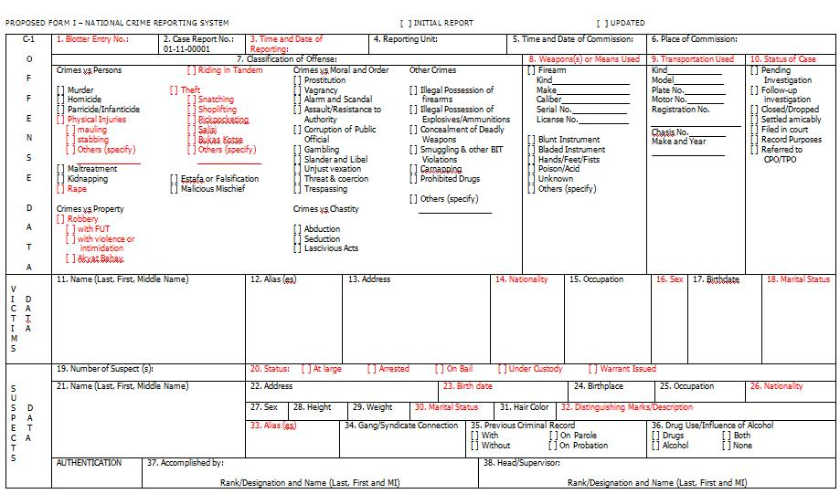

Figure 1. NCRS Form

. For example, in Figure 2, this map can tell you which area have highest physical injuries crime rate.

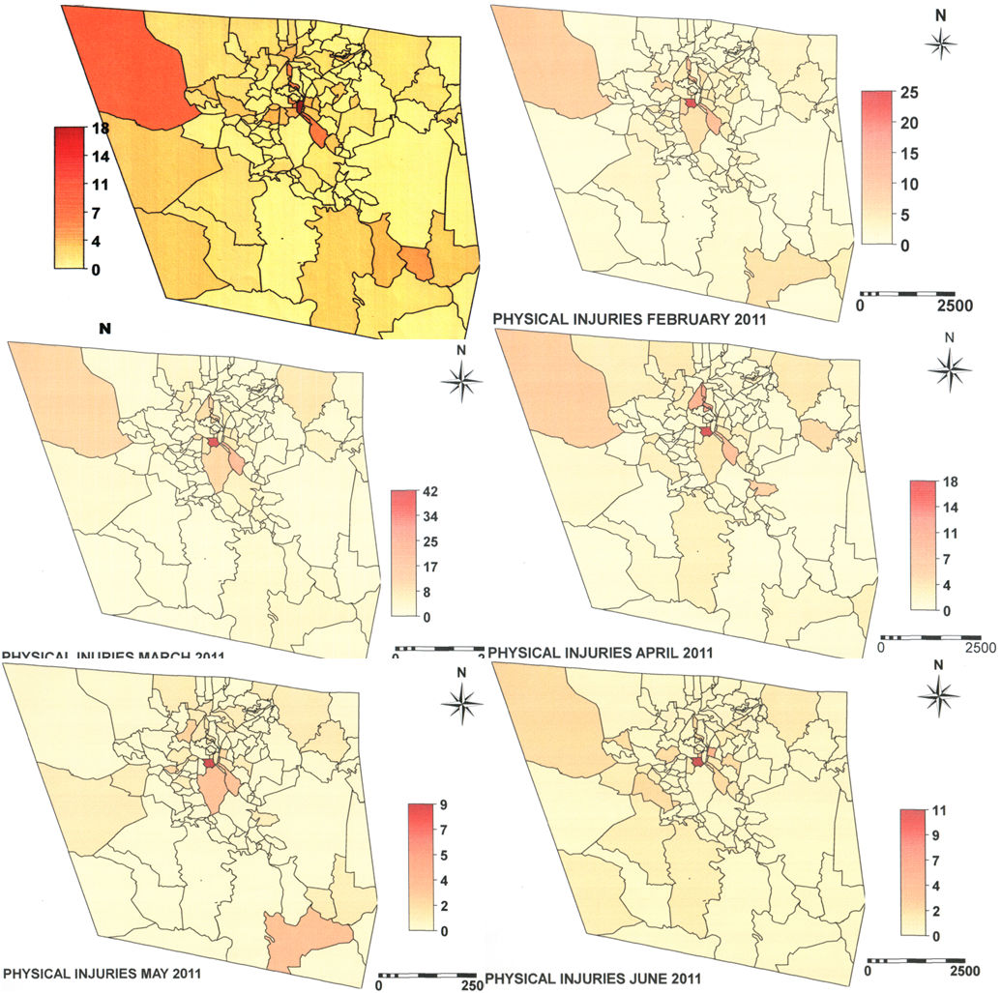

Figure 2. Physical Injuries Map: January to June 2011

The following were the issues and problems highlighted during the meeting.

  - Missing information in the form (Biometrics, picture, sex, height, BEN)
  - Inconsistencies with data entry (Title, Age, Birth date,)
  - Double entry
  - .Address of victim is not within Baguio.
  - Place of commission
  - Postponement encoding of forms because of insufficient data.

The following are the issues and problems highlighted during the presentation:

- multiple offense in one case
- multiple transport or no transport
- multiple weapons

Deliverables of the Project

1. Database Design (Prelim)

Database design is quite important to the system because it will define the structure of the system. This logical data model contains all the needed logical and physical design choices and physical storage parameters needed to generate a design in a Data Definition Language, which can then be used to create a database.

Normalization in database design was used to reduce data redundancies. Database normalization is a design technique for structuring relational database tables. Database theory describes a table's degree of normalization in terms of normal forms. The database was normalized in the third normal form (3NF).

- Design database using MySQL
- Create database
- Create necessary tables which includes but not limited to the following tables:
- Case Detail
- Crime Type
- Offense
- Weapon
- Suspect
- Victim
- Firearm
- Populate tables using data entry forms

2. Web- Based User Interface

- Add (Prelim)
- Edit (Prelim)
- Delete (Prelim)
- Extensive Queries (Midterm)
- Report Generation (Midterm)

3. Graph (Bar Graph, Line Graph, Pie Chart) (Finals)
3. Security of the System (User Management, Password, Level of Access, Encryption, Decryption, etc…) (Finals)
4. Connect to Google Maps (Finals)

